--Waterford West State School Tuckshop--

Snack Time
Muffin (homemade Banana, Berry) | $1.00
Fresh Fruit Salad | $2.00
Fresh Popcorn | 50c
Fresh fruit in season | $1.00
Yoghurt (Banana, Vanilla, Strawberry) | $1.00
Banana Bread (homemade) | $1.00
Chips (Honey Soy, Plain, Jumpys, Veg Chips) | $1.50
Carrot Sticks & Dip  Mini Pancake with Jam (homemade)  Custard (Vanilla)  Choc Chip Cookie  Boiled Egg | $1.00  $1.00  $1.00  70c  $1.00
Hot Food
Only available at 1st Break
Chicken Nuggets (4 pack) low fat | $3.00
Lasagna | $5.00
Four n Twenty Traveller Pie | $5.00
Chicken Burger  Hamburger  Cheeseburger | $5.00  $5.00  $4.50
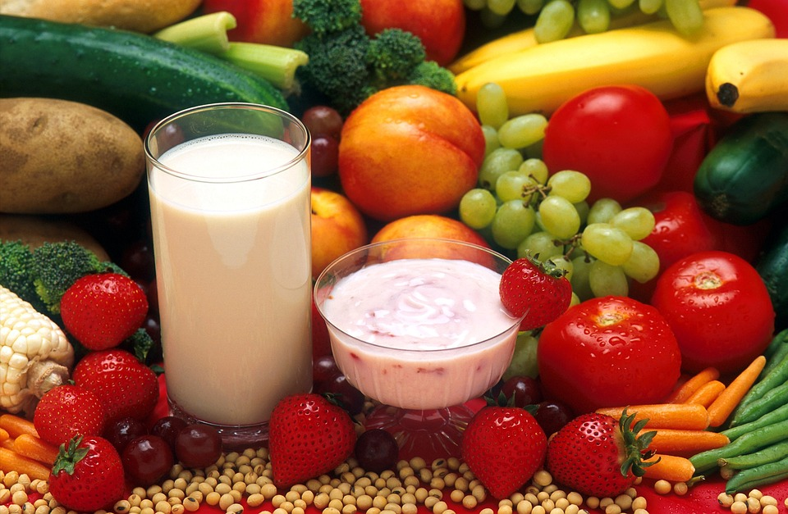
Sandwiches/Wraps/Salads
Jam/Vegemite/Cheese Sandwich |  | $2.50
Egg, Lettuce & Mayo Sandwich |  | $4.00
Ham & Salad Sandwich |  | $6.00
Chicken & Salad Sandwich |  | $6.00
Chicken West Side Wrap |  | $6.00
Chicken Caesar Salad |  | $6.00
Tuna/Ham/Chicken Salad Box |  | $6.00
Drinks
Plain Milk (300ml) |  | $2.00
Mighty Cool Choc Milk (250ml) |  | $2.50
Mighty Cool Strawberry Milk (250ml) | $2.50
Water (600ml)  100% Juice Poppers  (Apple, Tropical, Apple/Blackcurrant)  Glee  (Raspberry, Tropical, Bubble-gum Grape  and Watermelon flavours) |  | $2.00  $2.00  $2.50
Icy Treats
½ Ice block  Full Ice block |  | 50c  $1.00
Dixie Cup Ice cream |  | $1.50
Moosie Ice cream (Choc, Blue & Strawberry)  Juicee Fruit Tubes (Tropical & Wild berry) | $2.00  $2.00
Full menu available on
Munch Monitor
Prices subject to change without notice

